Connecting the Dots
By Charlene White

Consultations, Seminars, Speaking Engagements, and Educational and Training Materials
www.charlenewhite.com
charlene@charlenewhite.com
800-445-7805

New Patient Coordinator & Marketing Workshop
December 6, 2019 | New York, NY
Jay Suites Times Square

Mastering Practice Management Workshop
December 7, 2019 | New York, NY
Jay Suites Times Square

• • •

• • •

• • •

SCHEDULING

LACK OF SYSTEMS AND STANDARDS RESULT IN:

1.
2.

HOW EVERYONE PLAYS A ROLE IN MAKING THE SCHEDULE WORK:

DOCTOR:

BUS. STAFF:

NEW PT COORD:

ASSISTANTS:

CLINICAL SYSTEMS

LACK OF SYSTEMS AND STANDARDS RESULT IN:

1.
2.

HOW EVERYONE PLAYS A ROLE IN MAKING THE SCHEDULE WORK:

DOCTOR:

BUS. STAFF:

NEW PT COORD:

ASSISTANTS:

NEW PATIENT PROCESS

LACK OF SYSTEMS AND STANDARDS RESULT IN:

1.
2.

HOW EVERYONE PLAYS A ROLE IN MAKING THE SCHEDULE WORK:

DOCTOR:

BUS. STAFF:

NEW PT COORD:

ASSISTANTS:

COLLECTION SYSTEM

LACK OF SYSTEMS AND STANDARDS RESULT IN:

1.
2.

HOW EVERYONE PLAYS A ROLE IN MAKING THE SCHEDULE WORK:

DOCTOR:

BUS. STAFF:

NEW PT COORD:

ASSISTANTS:

MARKETING SYSTEM

LACK OF SYSTEMS AND STANDARDS RESULT IN:

1.
2.

HOW EVERYONE PLAYS A ROLE IN MAKING THE SCHEDULE WORK:

DOCTOR:

BUS. STAFF:

NEW PT COORD:

ASSISTANTS:

SCHEDULE FORECASTER FOR 2019

The purpose of forecasting the schedule is to create smooth flowing days. Light days and heavy days create stress in the office. It also creates front to back tension. It is important to put a structure in place to prevent this from occurring. On the next page there is a schedule forecaster for the year. Use this format to create your own in years to come. The instructions for using this are as follows:

- Mark off all weeks and days the office will be closed for seeing patients.
- Record the number of patients seen on the patient days on the line next to the date.
- Post this by the scheduling computers.
- Project where patients will be scheduled at your morning huddle.
- Look at how being out one-week effects the schedule six weeks out.
- This enables you to plan how the patients will be scheduled. Being proactive verses reactive reduces stress.

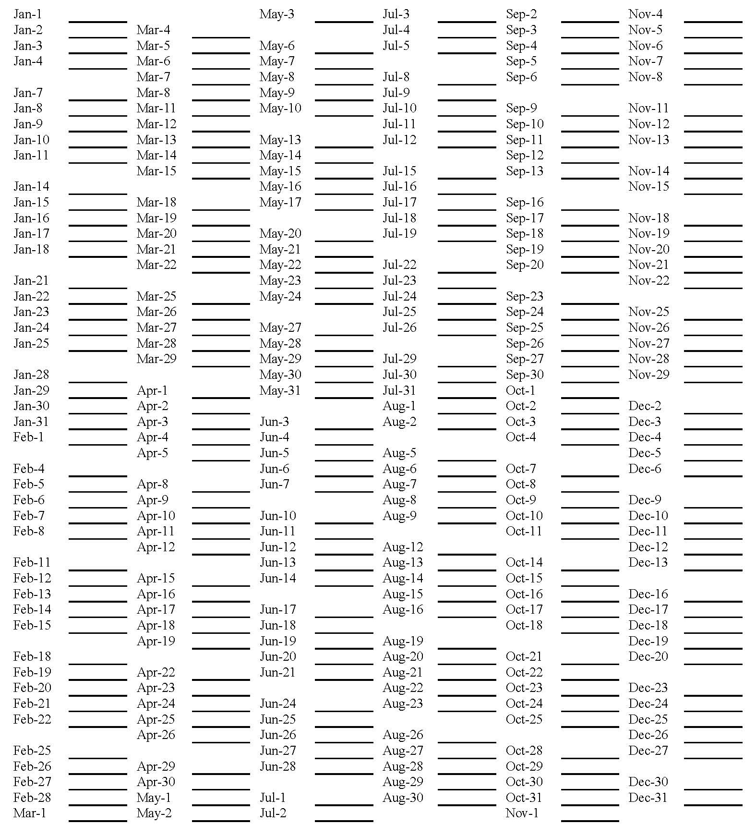

EMERGENCY TRACKING FORM
Sample

Patient’s Name: Date:

Bands/Bonds Off
Band(s) off tooth: # # # # # #
Bond(s) off tooth: # # # # # #
Product on tooth or appliance?
Which assistant prepped the tooth?
Patient’s comments:

Poking Wire
Wire type?
Who inserted the wire?

Other Emergency

NEW PATIENT INFORMATION SLIP

PATIENT’S NAME _____________________________

Thank you for choosing our office. I need to gather some information that will take about five (5) minutes. Is this a good time for you?

How did you hear about our office?

Do you have any friends or family members that are patients? No Yes,

Have you (or the child’s name) seen another orthodontist? No Yes

Who is your (or the child’s name) general dentist?

We will be happy to contact Dr. ‘s office (the dentist) and let them know you have made an appointment and how much we appreciate their referral. We will also check to see the date of your (or the child’s name) last cleaning and x-rays.

** If Adult Appointment – Ask **

What particular concerns do you have about your teeth that encouraged you to phone our office?

** If Child Appointment – Ask These Questions **

How does __________ feel about getting braces?

Do you have any particular concerns?

Besides you, will anyone else be involved in the decision to begin _______ treatment?
No Yes,

Dr. likes to make his/her patient’s feel welcome, he/she would like to know what ______________’s interests are.

** Go to Computer Screen **

Please excuse me for just a moment while I put some information into the computer so I can make your appointment. Enter basic name, address and phone number into the computer.

** Pull Up Next Available NP Appointment **

Do you have a particular day of the week that works best for you? Then offer two options.

My first available appointment is ______________. (move on once appointment is established)

If Dr. says that ____________ is ready to start treatment, the next step is to take diagnostic records, scan, photos, & x-rays. We can save you a trip by taking those during this visit. We will need to allow an additional half-hour for this. Would this be of interest for you? No Yes

If you have insurance coverage, please bring in your card and we will be happy to verify your benefits, or I’d be happy to take it now if that works for you.

Please plan on being here for approximately one hour, Dr. will tell you if treatment is needed, approximately how long the treatment time would be and our treatment coordinator will discuss fees and payment options with you.

Please visit our website for directions to our office.

Is there anything else I can provide for you?

Thank you for calling our office. I am sure you will enjoy your visit here. Dr. is a very nice person and a great orthodontist. We will see you on __________________.

Have a great day!!!!
CROSSTRAINING CHECKLIST
Cross-trained staff members are a valuable asset to the team. Give each team member a copy of this checklist to complete. Make it fun. See how many people can help out in how many different areas of the practice. (staff member) is trained to perform the following duties:

BUSINESS OFFICE:

Greet patients in the reception room
Order business supplies
Run monthly reports (production, collections, etc.)
Keep front office tidy
Sort mail each day
Follow-up on broken appointments
Keep on top of recalls
Collect payments
Confirm insurance
Send monthly statements
Assist in patient flow
Answer financial questions
Process auto payment
Turn on computers
Open up the office
Change messages
Schedule appointments
Set-up the schedule
Post payments
Run day sheets
Make deposits
Submit insurance claims
Close the office
Conduct new patient process
Conduct a deband conference
Process letters

CLINIC:

Keep track of inventory and stock each item
Clean and stock units
Set-up brackets for bondings each day
Instrument and handpiece maintenance
Take impressions
Fit bands
5-minute scan
Perform deband procedures
Take an emergency call
Keep on top of treatment overruns
Assist doctor in progress updates
Keep patient flow running smoothly
Seat bonded retainers
Take X-rays and photos
Change arch wires
Patient education at bonding
Assist doctor with clear aligner patients

LAB:

Trim models
Make Essex retainer
Print 3D models
Make Hawley retainer
Set-up indirect bonds
Assist in taking records
Know how to take care of a simple emergency

EVALUATING YOUR CURRENT COLLECTION SITUATION

Number of Contracts Number of Contracts Past Due
Number of Open Accounts Number of Accounts Past Due

Run a report of your:
Total
a. Delinquent over 30 only accounts
b. Delinquent over 60 only accounts
c. Delinquent over 90 only accounts

(The total of a, b, & c divided by your total number of contracts equals your percentage of past due contracts.)

Sample Chart of Past Due Contracts

# of Contracts | 5% | 10% | 15% | 20% | 25%
300 | 15 | 30 | 45 | 60 | 75
400 | 20 | 40 | 60 | 80 | 100
500 | 25 | 50 | 75 | 100 | 125
600 | 30 | 60 | 90 | 120 | 150
700 | 35 | 70 | 105 | 140 | 175
Excellent------------------------------------------------------------------→Needs Improvement

Other Areas to Evaluate:

- What was your amount written off for bad debts last year? Ideally, 2% or less of gross collections? (i.e. $800,000 collections /$16,000 or less written off)
- Do you have old past due accounts that need to be written off?
- How many patients in retainers have accounts that are past due?
- How many contracts are paid out and the patients are still in braces over their target date?
- Are your insurance accounts current?

MARKETING CALENDAR

I recommend setting up a Marketing Calendar each year. The following is a sample design. Establish a target date for implementation of each idea.

MARKETING CALENDAR FOR

 | KIDS | PARENTS | STAFF | COMMUNITY |  |  |  | REFERRING  OFFICES
JAN | Appt. Card Contest |  |  |  |  |  |  | Visit 5 Offices
FEB | Valentine’s Day  Contest | Order Hand Mirrors  (Gift for Parents) |  | Dental Health Mth.  Display Booth (mall) |  |  |  | Invite Staff in 5  Offices
MAR | Decorate for St.  Patrick’s Day |  | Pot Luck Dinner |  |  |  |  | Invite Staff in 5  Offices
APR | Easter Contest | Contest for Parents | No Patient Day-  Springs Clean &  Eat Pizza |  |  |  |  | Invite Staff in 5  Offices
MAY | Vacation Postcard  Contest |  |  | Speaking  Engagement for  Women’s Legion |  |  |  | Office Open House
JUN | Swimming Party | Swimming Party for  the Family | Progressive  Concepts Course,  Myrtle Beach, SC | Sponsor Softball  Team |  |  |  | Sponsor Continuing Ed.  Course
JUL | Decorate for 4th |  | Wear Red, White  and Blue |  |  |  |  | Visit 5 Offices
AUG | Staff Baby Picture  Contest |  | Office Swimming  Party | Sponsor Community  Blood Drive |  |  |  | Invite Staff in 5  Offices
SEP | Back to School  Pencils/Book Covers |  | SURPRISE! Slow 1st week of school -  Day Off with pay! |  |  |  |  | Invite Staff in 5  Offices
OCT | Halloween Contest |  |  |  |  |  |  | Invite Staff in 5  Offices
NOV | Skating Party | Skating Party | Decorate for  Thanksgiving |  |  |  |  | Invite Staff in 5  Offices
DEC |  |  | CHRISTMAS PARTY - Decorate  Office for Kids | Sponsor a Needy  Family for the  Holidays |  |  |  | Deliver Holiday  Goodies to Offices
GENERAL IDEAS:

- Office T-shirts
- No-No Bag at Deband
- Thank You Notes for Referrals
- Banding Calls
- Social Media in the Dental Office $9.95 ADA Catalog

PRACTICE SYSTEMS ANALYSIS QUIZ
Answer the Following Questions True (T) Or False (F)

SCHEDULING

- We rarely get a complaint from patients regarding waiting to be seen.
- We have an organized scheduling template.
- We focus on reducing repairs.
- We can get key production appointments scheduled in ten days.
- We have appointment book guidelines that we follow.

Total number rated True _____ Total number rated False _______

CLINICAL

- We have our band and bond failures under control at 5% or less.
- We have a good system to direct the doctor patient to patient.
- Our efficiency and harmony is not disrupted by front to back conflict.
- Our assistants share equally in the patient load.
- We do an excellent job of informing our patients and parents throughout treatment.

Total number rated True _____ Total number rated False _______

NEW PATIENT PROCESS

- We are quite pleased with our case acceptance.
- We know we project an excellent image.
- Our new patients are not kept waiting longer than 5 minutes for the doctor or coordinator.
- We offer same day starts.
- Our payment plans and fees are affordable to the majority of our patient base.

Total number rated True _____ Total number rated False _______

MARKETING

- We have a written annual marketing plan.
- We have an annual marketing budget.
- Our staff has allocated time to market.
- We are pleased with our new patient numbers.
- Both our office image and quality of results are excellent.

Total number rated True _____ Total number rated False _______

COLLECTIONS

- We promote auto payment.
- We are insurance friendly.
- We have less than 5% of our accounts past due.
- We fully inform the responsible party up front regarding finances and collections.

Total number rated True _____ Total number rated False _______

Grand total rated True _______ Grand total rated False ________

Rating Scale:

25-22 true answers is excellent

21-18 true answers is good

17 or less true answers, indicates you need to get to work immediately on the key systems in your office to enhance the atmosphere and production for everyone involved.

Review your answers and set target dates for implementation.

WHAT ARE YOU WILLING TO DO?

WHAT AREAS IN YOUR PRACTICE COULD BENEFIT FROM CLEARER STANDARDS?

1.
2.
3.

WHAT AREAS IN YOUR PRACTICE COULD BENEFIT FROM CLEARER ACCOUNTABILITY?

1.
2.
3.

LIST THE SPECIFIC AREAS THAT ARE A SOURCE OF FRUSTRATION AND STRESS FOR YOU?

1.
2.
3.

WHAT SYSTEM COULD YOU PUT INTO PLACE TO ELIMINATE THE STRESS AND FRUSTRATION?

1.
2.
3.

WHAT ARE YOU WILLING TO DO?

BY WHAT DATE?
POP QUIZ

Circle the point value that accurately applies to each question concerning your office.

 |  | Point Values
 |  | Yes | Sometimes | No
Do you hear a lot of laughter in your office? |  | 3 | 2 | 1
Does the staff smile a lot? |  | 3 | 2 | 1
Do you look forward to doing fun things together |  | 3 | 2 | 1
Are birthdays celebrated in your office? |  | 3 | 2 | 1
Is there a lot of communication at your staff meetings? |  | 3 | 2 | 1
Does the staff look forward to staff meetings? |  | 3 | 2 | 1
Are you continuously learning together as a team? |  | 3 | 2 | 1
How do people react when a mistake is made? (supportive = yes, apathetic = sometimes, fearful = no) |  | 3 | 2 | 1
Does the staff come forth with lots of ideas? |  | 3 | 2 | 1
Do you have lunch together often? |  | 3 | 2 | 1
TOTALS (add your circled answers to get column totals)

Scoring: 24 or more in the “Yes” column is EXCELLENT.

21-23 in the “Yes” column is GOOD.

18-20 in the “Yes” column is AVERAGE (never strive to be average).

Less than 18 in the “Yes” column means your team NEEDS FOCUS on team spirit.
TEAR THE PAGE

