**ROSEMARYBRAY**

***Speaking, Training & Consulting to the Dental & Orthodontic Profession***

***The North East Society of Orthodontics***



***Presents Their 2019 Annual Session in Boston***

With a Lecture By

***Ta Dah!!!***

Rosemary Bray

On Saturday Sept 28th, 2019

***“Memorable First and Last Impressions ”***

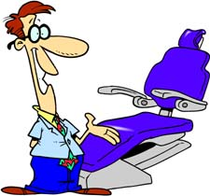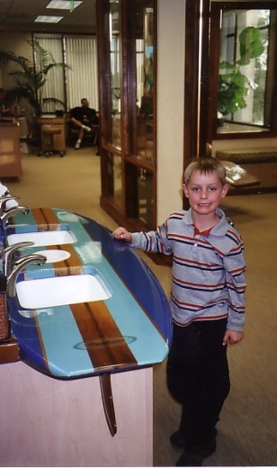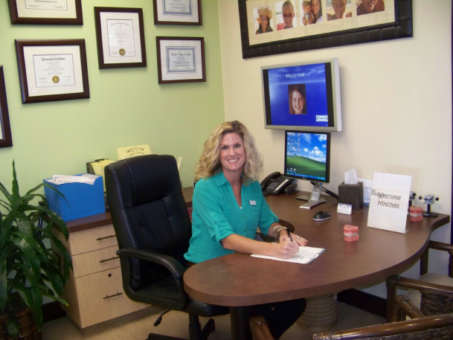

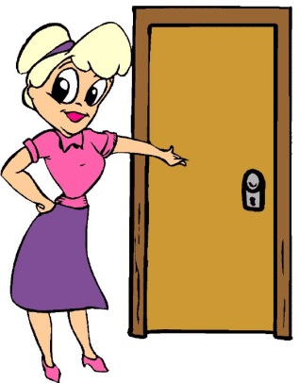*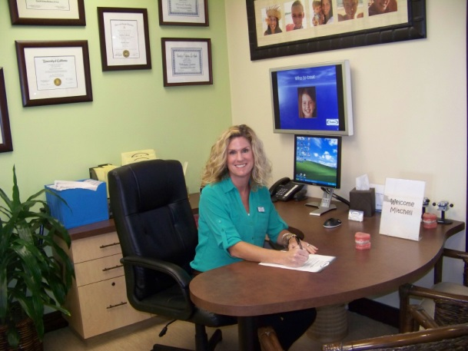Rosemary Bray*

**VIP Ortho Pts**

6263 Paseo Callado

Carlsbad, CA 92009

Tel/Fax 760.268.0760





Email : Rosemarybrayortho@gmail.com

Website : [www.rosemarybray.com](http://www.rosemarybray.com)





*~ Please do not reproduce or distribute this copyrighted material ~*

*After 50 Years in the Profession, Rosemary Believes That A Successful, Dynamic, Quality, Profitable, Ortho Practice Is A*

*Balance In 3 Equal Focus Areas ~*

*1/3 = ____________________________________*

*1/3 = ____________________________________*

*1/3 = ____________________________________*



***“Service”*** *according to Mr Webster, is* ***_________________________________________________________________________________________________________________________________________________________________________________***

**

*People Want, Need and Buy Only 2 Things ~ They Are ….*

**

1. *____________________________________*
2. *____________________________________*

*When Patients Come To Any Ortho Office, Including YOURS, Which Are They “Buying”??? __________*

***Establishing Relationships and Developing Rapport and Trust Is***

***Your Number One Job Responsibility***



Zig Ziglar Taught Us ~ When people like you they listen to you but when they TRUST you, then they do business with you. Therefore it is critical to create TRUST early on.

*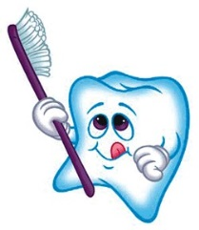****YOUR ORTHO PRACTICE SUCCESS CYCLE***

R

Being successful in ANY business is all about ___________________ and your ability to be a

!

R

P

M

______­­­_______ of ____________ ____­­­____________

***15 %*** *of one’s financial success is due to technical knowledge*

***85 %*** *is due to skill in human engineering, to personality & the ability to lead people*

(Carnegie Foundation for the Advancement of Teaching)

*In ALL Ortho Practices, those people are your patients, their families, your referring offices, the community at large and each other in the office.*

**

**#1**

___________________________________________________________________________________________________

___________________________

**# 5 #2**



**# 4** **# 3**

**SAID YES**

E

Everyone Must Provide An Extraordinary ________________

For **E_______** Patient * * * At **E_______**Visit.



That Means Me, __________________________

*According To Forbes Magazine ~ People Judge Others Based On Four Criteria ~*

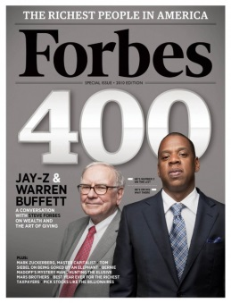

1. *________________________________________________*
2. *________________________________________________*
3. *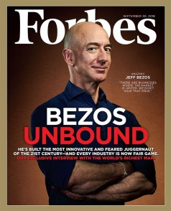________________________________________________*
4. *________________________________________________*

***Your Verbal Communication ~*** Some most interesting statistics I have learned about Verbal Communication are that:

1.) ___ % of your message is - *the actual choice of words you use*

1. ___ % of your message is - *the tone of your voice, the speed, the pausing, the up,*

*the down, the soft, the loud . . . what we call the*

*inflection*

##### 3.) ___ % of your message is - your body language, what you do with your eyes, your

##### hands, your smile, or lack of, do you touch, do

##### you move, do you stand or sit, do you look comfortable

##### or rigid?

**

***Why Should We Want To Communicate Well? 5 Good Reasons !!***

1. ___________________________________________________________________
2. ___________________________________________________________________
3. ___________________________________________________________________
4. ___________________________________________________________________
5. __________________________________________________________________

*(In the 1st ____ seconds after meeting you, people visually size you up and in the first ____seconds, they decide if they like you or not!)*

* Be enthusiastic! Love what you do ~ Do what you love!
* Smile ~ what is the business you are in???
* Use their names and do it often ~ teach yourself to memorize
* Utilize eye contact ~ especially when talking money
* Use Mirror Imaging ~ Body movements, Tone of voice, Speed of speech
* 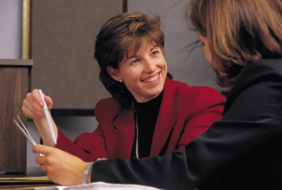Give patients your full attention, no phone calls taken, avoid interruptions, do not leave them alone if at all possible
* Be sincere ~ if you “try” to make a good impression that is the impression they will get from you ~ so be sincere and you’ll need not fake it
* Get people to talk about themselves ~ use the 80/20 rule ~ it makes sense

(80% about them and only 20% about yourself)

* Respond from the heart ~ care about people and be real ~ sure makes it easier!
* Be spontaneous and be confident
* Keep your commitments ~ when you say you will call them today,

please call them today, always do what you say will do

* Deliver more than you promise ~ always promise people less than you will deliver and then deliver more than what you promised
* Dress for success ~ look like the bank manager. When you are dressed up you actually behave differently and more professionally. It shows!

Having A ***“10 Ft Attitude”*** Means __________________________________

______________________________________________________________

***C:\Users\Rosemary\AppData\Local\Microsoft\Windows\Temporary Internet Files\Content.IE5\A8I5P16B\ExclamationPoint[1].png***______________________________________________________________

This philosophy, believe it or not, was created by Mr. S________ W___________

***Do You Have One??***

**Attitude**

***The Top Things That Upset Patients ~*** (from patient satisfaction surveys)

1. *Being ________________________________________________*
2. *Getting ________________________________________________*
3. *Being _________________________________________________*
4. *Inadequate _____________________________________________*
5. *You don’t ______________________________________________*
6. *You fail to ______________________________________________*

If One of Biggest Complaints in Communication Surveys is B_________ I __________ ~ Then make a commitment you will not do that to your patient. Especially early on (phone or greeting).

DRs do this in an average of_______ ______________________!

***The Main 5 Complaints About Telephone Etiquette ~***

1. *____________________________________________*
2. *____________________________________________*
3. *____________________________________________*
4. *____________________________________________*
5. *____________________________________________*

***A Word About My Personal Pet Peeve ~***

When your patient, or anyone, says ***Thank You*** for doing something wonderful for them, try saying . . . “It was my pleasure” or “I’m so glad I could do that for you” or “Oh I’m so happy that worked out well too!” Instead of the awful, boring and terribly overused . . . **N____ P___________ ☹ .**

Accept the appreciation or compliment! Too often a genuine thank you or a compliment is discounted or thrown aside by saying it was not a P___________. Another great reason not to say that is merely because everyone else does! Be different, stand out, and make people remember you because of your wonderful ability to communicate well and to be different than the norm.

“We’re so happy that you are happy with us Mary. We work hard to hear compliments like yours. I bet Dr ____ would love it if you would put that on a review for us. It would keep all of us trying hard to please our patients. ”



I’ll take that come back any day compared to N______ P___________!

MCj04404240000%5b1%5dA Few Favorite Helpers Are ~

*Raving Fans . . . . . . . . . . . . . . . . . . . . . . . . . . . . . . . . . . . . . . . . . . . . . . . . . . . . . .Ken Blanchard The One Minute Manager . . . . . . . . . . . . . . . . . . . . . . . . . .Ken Blanchard and Spencer Johnson*

*How to Win Friends and Influence People. . . . . . . . . . . . . . . . . . . . . . . . . . . . . . . Dale Carnegie*

*Crucial Conversations. . . . . . . . . . . . . . . . . . . . . . . . . . . . . . . . . . . . . . . . . . . . . Kerry Patterson*

*When Fish Fly . . . . . . . . . . . . . . . . . . . . . . . . . . . . . . . . . . . . . . . . . . . . . . . . . . . John Yokoyama*

** Given Today as a Prize

*How to Make People Like You in 90 Seconds . . . . . . . . . . . . . . . . . . . . . . . . . . . Nate Boothman*

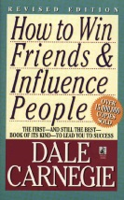*The 7 Habits of Highly Effective People . . . . . . . . . . . . . . . . . . . . . . . . . . . . . . . .Stephen Covey*

*Relationship 101 . . . . . . . . . . . . . . . . . . . . . . . . . . . . . . . . . . . . . . . . . . . . . . . . . . John Maxwell*

*The Power of Body Language (8 CD set only) . . . . . . . . . . . . . . . . . . . . . . . . . . . Joe Navarro*

*The Little Green Book of Getting Your Way . . . . . . . . . . . . . . . . . . . . . . . . . . . Jeffrey Gitomer*

*The Little Black Book of Connections . . . . . . . . . . . . . . . . . . . . . . . . . . . . . . . . Jeffrey Gitomer*

*Positive Words, Powerful Results . . . . . . . . . . . . . . . . . . . . . . . . . . . . . . . . . . . . . . . .Hal Urban*

** Given Today as a Prize

*The How of Wow . . . . . . . . . . . . . . . . . . . . . . . . . . . . . . . . . . . . . . . . . . . . . . . . . . John Murphy*

*Setting the Table . . . . . . . . . . . . . . . . . . . . . . . . . . . . . . . . . . . . . . . . . . . . . . . . . . .Danny Meyer*

*Dealing With People You Can’t Stand . . . . . . . . . . . . . . . . . . . . . . . . . . . . . .Dr Rick Brinkman*

*How To Win Customers and Keep Them For Life . . . . . . . . . . . . . . . . . . . . . Michael LeBoeuf*

*Fabled Service . . . . . . . . . . . . . . . . . . . . . . . . . . . . . . . . . . . . . . . . . . . . . . . . . . . Betsy Sanders*

*The Nordstrom Way . . . . . . . . . . . . . . . . . . . . . . . . . . . . . . . . . . . . . . . . . . . Spector/McCarthy*

*Delivering Knock Your Socks Off Service . . . . . . . . . . . . . . . . . . . . . . . . . . . Anderson/Zemke*

*Coaching Knock Your Socks Off Service . . . . . . . . . . . . . . . . . . . . . . . . . . . . Anderson/Zemke*

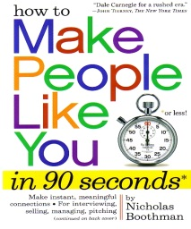

Given Away Today As Prizes!

***My 2 Promises =***

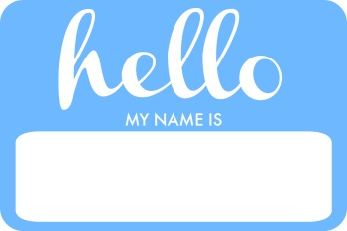***Never Expect Your Nametag Never Expect “Guys”***

***To Replace Your _________ To Replace _________ _____________ _______________***

Rosemary

Notes ~ ________________________________________________________________________

________________________________________________________________________________________________________________________________________________________________________________________________________________________



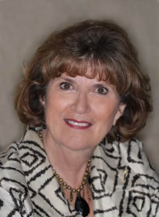 **Meet Your Speaker**

Rosemary Bray spent more than *30 years* employed in the Dental profession, with experience in General Dentistry, Periodontics and Orthodontics (18 years).

Her last 16 years were as *Office Manager* and *Treatment Coordinator* for a quality San Diego Orthodontic practice. She left in late 1998 to begin self-employment as a speaker and consultant in Orthodontics and Dentistry. She was one of the founding members of the *Pacific Coast Treatment Coordinators* *Study Group* and also of the *San Diego Dental* *Office Managers Study Club.* Rosemary has just proudly celebrated her **50th** anniversary in teeth! ***Yes, that was 50!!***

For two years, she taught oral hygiene and Dental care to *400 children* from *37 different countries* at the International Community School of Zurich while she and her family lived in Zurich, Switzerland for a 4 year period. A tooth brushing program was instituted in the primary school curriculum as a result and her program is still ongoing today. Those International School kids are brushing their teeth! ☺

**She has lectured/worked *nationally in ALL 50 states and internationally* on every continent except Antarctica on behalf of the AAO & every constituent such as NESO, most Orthodontic companies, various dental societies, and Ortho and Dental study groups and for her own workshops and seminars. In 2011, she was honored to be the Staff Program Co-Chair for the AAO Annual Session and has been featured on 25 consecutive AAO programs. She is a feature speaker at most Dental meetings too, such as the RMDC, ADA, CDA, Yankee Dental, Star of North and of the South, AAPD, Dallas Dental, Chicago Mid-Winter and the prestigious Hinman.

Rosemary is the Past President and Board Member of the *San Diego Children’s Dental Health Association* (a non-profit Dental clinic in San Diego which treats approximately 500 needy children each month). This is a last resort care facility which relies on donation alone to operate. In 2007, they began to finally provide Orthodontic care as well as quality Dental care!

She has been a visiting *Clinical Instructor* in the Orthodontic department of the University of the Pacific School of Dentistry in San Francisco where she has donated her knowledge and experience to the future Orthodontists studying there and she has spoken at most Orthodontic schools as a gift back to the profession.

She serves on the Board of Directors for the American Association of Orthodontics Foundation **(AAOF),** which supports and promotes education and research in orthodontics. Rosemary’s also served on the Education Committee for the Pacific Coast Society of Orthodontists **(PCSO)** and has assisted in planning numerous Annual Sessions for that society.

Rosemary is self-employed as an ORTHO *office trainer and consultant* specializing in

New patient exams, TC Training Internal and external marketing

Outstanding customer service Verbal and written communications skills Team relationships, motivation, incentives, retreats and team building

She gives *personalized office retreats and seminars* and is available for speaking engagements to a variety of professional groups. A popular lecture is her ***Appreciation Seminar*** to thank the GP referrals to the Ortho Specialist for supporting the practice.

*She Travels The World In The Name Of Teeth And Smiles*

www.rosemarybray.com